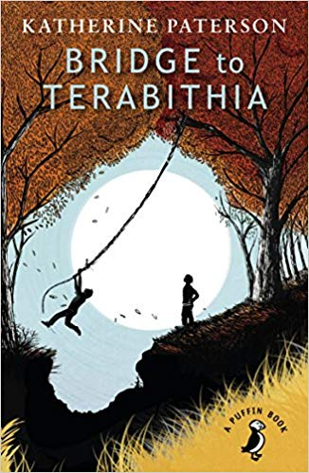
Bridge to Terabithia
Maebh McConnell 03/12/2019
Bridge to Terabithia is a book written by Katherine Patterson. I think that it is a contemporary fiction book.
The main characters in the story are Jesse Arons and Leslie Burke. Jesse’s family live a simple life and they have a lot of rows. Leslie’s an only child, from ‘’the big city’’ who is from an artistic and rich family, while Jesse’s family is quite poor.
In the book, Leslie’s family moves to the country side for Leslies benefit but Leslie doesn’t really fit in because she wears ‘funny’ clothes and has a city accent. Since Jesse doesn’t have any friends either he ends up making friends with Leslie. The Terabithia part in the book, is when Jessie’ and Leslie make up an imaginary land called Terabithia. In Terabithia they are King and Queen.
I wouldn’t really pick Terabithia out myself, but it’s ok. My favourite part in the book is when they trick Janice Avery in to thinking she had a date (they did this after she stole Jessie’s sister’s ‘Twinkies’).
The parts I didn’t like was when it was just normal everyday trivia. The parts which did catch you up were either sad or a bit weird.
I would recommend it to someone who likes slightly sad books with a few funny bits. I give it two stars.

BRIDGE TO TERABITHIA REVIEW; BY JULIANNE DODD

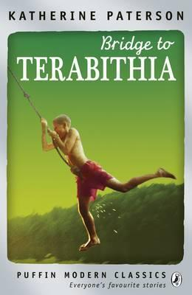
Bridge to Terabithia is a beautiful realistic fantasy novel written by Katherine Patterson for children of all ages. It features two child heroes, Jesse and Leslie, who discover the magical land of Terabithia, a place of endless possibilities that only exists in their imaginations. Here, Jesse is a king, and Leslie is a queen.
In Terabithia, Jesse and Leslie feel like strong and powerful monarchs instead of small, skinny ten- year –olds. They use their adventures in Terabithia to tackle real life problems. I thought that this part was lovely, because it really shows that no matter how young you are, you can always sort things out yourself.
The story is set in 1970s America. It is quite interesting to read a book set in that time, since most books today are set in the present. Jesse’s family are quite harsh with him. Leslie’s family, however, are kind and happy.
The two children meet when Jesse is doing chores in the field. He comes across Leslie, a gutsy girl of ten. The duo instantly become friends. At school, Jesse is determined to be the fastest child in the 5th grade. However, during a race at school, Jesse is beaten by Leslie, making her the fastest, not Jesse. But he learns to accept it.
I really enjoy the chemistry between the two. It really shows that your friends can be the most important thing to you at such a young age.
However, like in most books, things aren’t always perfect. Leslie drowns on her way to Terabithia. This leaves Jesse devastated and alone. He then has to keep the magic of Terabithia alive, as he never was in charge of what happened in Terabithia. I had mixed feelings about this part. I was sad that Leslie had died, but interested in what Jesse was going to do about it.
I would definitely recommend this book to one of my friends as it is funny, interesting, emotional, and exciting. It’s a very mature novel, but I admire that the author didn’t dumb it down for children. I really enjoyed reading Bridge to Terabithia, and I hope that other people also enjoyed and will enjoy it as much as me.

I would rate this book four and a half stars.

Bridge To Terabithia book review
by Ben Fromholz
Bridge To Terabithia is a contemporary fiction book written by Katherine Paterson in 1977.
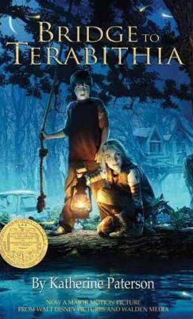
The book was set in the countryside of Washington. It is about a boy called Jess who wants to be the fastest kid in fifth grade that is until he meets Leslie who soon becomes his best friend.
Together they create the imaginary land of Terabithia where they rule as king and queen. I didn’t really like the book because it didn’t have enough action or stuff happening and the author seemed to drag on using pointless conversations to fill in gaps in the little action it had. It was also quite boring because when there was action it was small and quite uneventful.
My favourite part was when Leslie died because it was quite unexpected and eventful.
I didn’t like the book there is a lot I would change I would also add in an even that would give the book meaning and excitement.
I don’t know if the book has any moral unless you call `Never swing on a rope over a flooded creek bed` a moral.
I would not recommend it to anyone as I found it very boring dull.

I would not’ve read it if I hadn’t already read it.

Bridge to Terabithia book review
By Anna Butler
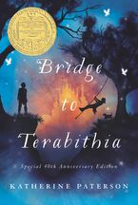
Bridge to Terabithia is written by Katherine Paterson. There is a bit of fiction, fantasy and is a family drama. It is set in the 1970s.
It is set in America. The main character is called Jess, he is 10 years old. He lives with his four sisters on a farm. He met a girl called Leslie, who just moved in to the house down the road from Jesse’s. At first he doesn’t like Leslie. He finds her annoying but then he begins to like her.
When Leslie and Jess become friends and decide to have a place for themselves, a magical place for themselves, where only they can go. They then create Terabithia where they are kings and queens. To go to Terabithia you need to cross a creek bed by swinging on an old rope.
I didn’t really like the book, I thought there wasn’t a lot of variety and it dragged on a lot. I also think that Leslie shouldn’t die. Maybe she could hit her head or something but not die. I think I would have preferred if there was more exciting bits of fantasy in the book.
My favourite part of this book is when Janice Avery gets fooled by Jess and Leslie. They both put a love letter in her school desk and said to meet her behind the school while she missed her bus ride home. That at part was very funny.
I would not recommend this book to a friend because I think they would find it a bit boring. I would probably rate this book

Bridge to Terabithia Review
By Adam
Bridge to Terabithia is a realistic fiction book by Katherine Paterson which was written in 1977.
The book is set in the 1970s in America. I do think the setting was appropriate. The main characters are Jess Aarons and Leslie Burke, two best friends. Other characters are May Belle, Joyce Anne, Brenda, Ellie, Jess and Leslie’s parents, Janice Avery and Miss Edmunds.
One day Jess sees that a family of three are moving into the old house next door called “the old Perkins place”. It turns out that it is Leslie and her parents who have moved in next door. The Aarons and the Burkes have never met before but got on really well. Jess and Leslie create the magical land of Terabithia. Jess goes on a trip with his teacher and when he gets home he finds Leslie dead.
My favourite part in the book was when they trick Janice Avery.
I didn’t really enjoy this book because it wasn’t very interesting and it dragged a lot.
I would give this book:

