A book review on Holes by Joshua Divilly

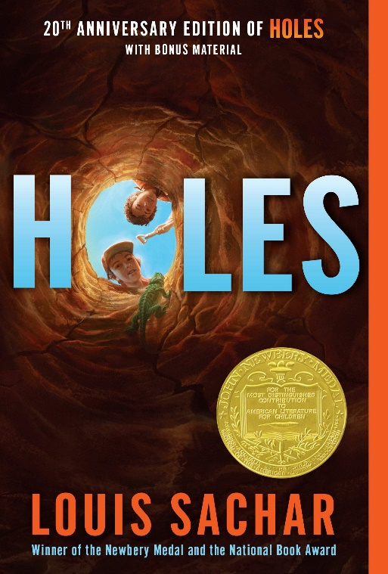
Holes is a book by Louis Sachar. It is a mystery and adventure book that is fiction. It is set in Texas, America.

The main characters are Stanley Yelnats, the Warden, Mr.Sir, Armpit, Squid, Zero, X-ray, Zigzag, Katherine Barlow and Sam the Onion Man.

What happens is Stanley gets arrested wrongfully for stealing some famous shoes. He goes to a juvenile detention centre were they are made to dig holes in order to make them better people but Stanley thinks they are digging for something else. While Stanley is there he makes some friends. Whose names are Zigzag, Armpit, X-ray, Squid and Zero. But he also runs into some enemies The Warden and Mr.Sir.

My favourite part of the book is where Stanley’s bad luck runs out and he starts having some luck and his family are no longer poor.
I wouldn’t change anything about this book. This book is a really exciting book in my opinion.
I think the moral of this story is to never give up because when everything seemed like it couldn’t get worse, Stanley didn’t give up.
I would really recommend this book to all ages.
I would give this book 5 stars and I think this book is really interesting and adventurous.

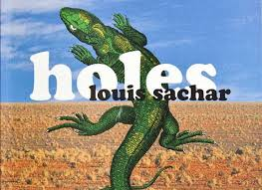
Holes book review 15th October 2019
By Eleanor

Holes, a book by Louis Sachar, is a fictional adventure book, with lots of links and mystery.
It is mainly set in Texas, America. The main character, Stanley Yelnats, gets sent to Camp Green Lake ( a vast, boiling, dried up lake with no water in it) for a crime that he never commited. At Camp Green Lake, he meets Zig Zag, X-Ray, Squid, Armpit, Twitch, Magnet and Zero. Some of the adults at Camp Green Lake were the Warden, Mr Pendanski and Mr Sir.
At Camp Green Lake, all the boys there have to dig holes, five feet up and five feet wide, even in the hot sun, the boys have only a little water to keep them going while they dig, it was worse than prison. Some of the characters I liked and some of them I didn’t like. I think my favorite character is Zero. I don’t like Armpit because he seems very aggressive, I don’t really mind Twitch, Magnet, ZigZag, Squid and X Ray. I thought all the settings were very good.
Stanley Yelnats goes to Camp Green Lake for a crime he never committed. At Camp Green Lake they have to dig holes, there are lots of boys there including Zero. Everyone was mean to Zero (apart from Stanley) because they thought there was nothing in his head. There was a curse on Stanley’s family from many years ago but Stanley breaks the curse when Zero runs away and Stanley goes to find him. Then he carries him up God’s Thumb and sings him the song that his great great grand father was supposed to sing to Zero’s great great grandmother when he was only fifteen. When they return to Camp Green Lakea lawer comes and takes him and Zero home. I really liked the book.
I think my favourite part was when they were at God’s Thumb because it was very captavaiting. None of the parts made me scared but a lot of the parts made me laugh.
I wouldn’t change anything.
I don’t think there was a moral of the story.
I would recommend it to a friend because it is a very good book and it is very funny.

Book review by Elliot
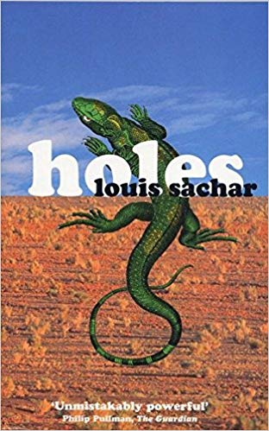
The author of Holes is Louis Sachar. It is a fiction kind of book, it’s also a kind of mystery and there’s a bit of action in it.

It was set in Texas, America. The main character is Stanley Yelnats, Zero and Kate Barlow. I did like most of them but I didn’t really like x-Ray because he only cared about himself and made Stanley give him the lipstick lid.

The plot is that Kate Barlow hid Stanley’s great, great, great, great, great Grandfather’s chest and the warden’s family has been searching for it for generations. Then they turned it into a juvenile detention centre. Stanley got arrested when a pair of Clyde Livingston’s shoes fell from a high way and fell on Stanley’s head because Zero stole it from a homeless shelter and dropped it on the high way because the cops were coming. Then when Stanley had them the cops got him they arrested.
I would recommend it to anyone who hasn’t read it before.

Holes Review
By Beth Doyle

Holes is a wonderful book by Louis Sachar. It adventure fictional book.

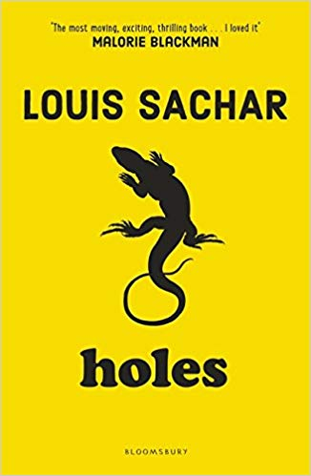
The main characters are Stanley Yelnats, Zero ( Hector Zeroni) the Warden, Mr Sir, and Mr Pendaski.
The story starts where Stanley is supposed to have stolen, famous baseball player, Clyde Livingston’s shoes. Stanley is sent to Camp Green Lake, (It’s a juvenile centre for boys). Next we meet X-ray,
Armpit, Squid, Zigzag, Magnet and of course Zero.

The boys are forced to dig a five foot hole once a day while the evil Warden and Mr Sir sit in an air-conditioned cabin.
One day Zero gets fed up and runs off to the desert. Stanley has to find him and runs off too.
After searching for a while, Stanley finally finds Zero under a boat. Stanley and Zero are walking back to camp and they decide to take a trip to God’s thumb. While they’re climbing Zero gets sick and faints, (probably from the splosh they had earlier, a different story). Stanley has no other choice but to carry Zero up the mountain.
Will they survive the harsh conditions? Try reading the book to find out.
Would I recommend Holes to a friend? YES!
I give Holes a five star rating.

A Book Review on Holes by Polly 15th October 2019
Holes, by Louis Sachar, is a fictional adventure book, with lots of mystery involved.
The book is based in Texas, America. Stanley Yelnats, the main character, whose family is supposedly cursed with bad luck, is sent to Camp Green Lake for a crime he never committed. There, he meets X-Ray, Armpit, Squid, Twitch, Magnet, Zigzag and Zero. Mr. Sir, Mr. Pendanski and the Warden are other characters, and Derrick Dunne is mentioned a lot, although you never actually come across him in the book.
There are two stories going on in the book. One is about Stanley’s family history, and about Green Lake before it dried up, and the other is about Stanley’s time at Camp Green Lake. Every day, at Camp Green Lake, the boys have to dig a hole, five feet deep and five feet wide. As Mr. Sir says, “This isn’t a Girl Scout Camp.” The Warden says that the reason the boys must dig the holes is ‘character building’ but it is a lie.
I think my favourite part of the book was the story of Elya Yelnats and Madame Zeroni. I liked that part of the book because it ended happily and it was funny. I laughed when I got the image of ‘Myra Menke with a head like a flowerpot’.
I did not really enjoy this book because I found it a bit depressing sometimes, where nothing really went right, but I did enjoy trying to match up the links and solving the mysteries which is always fun.
I think there could be a few morals to the story, like don’t steal and don’t judge a book by its cover.
I think that it would depend on the type of books my friend likes, because I did not really like it, but my friend might like it.

